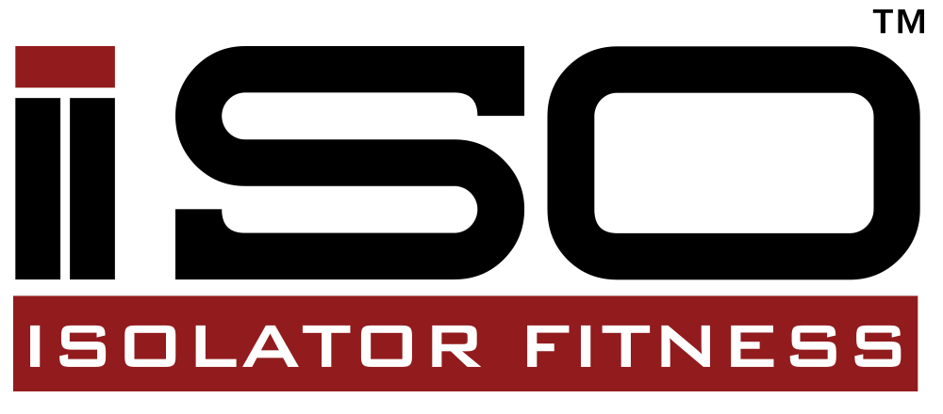
Coupon Influencer Campaign

Program Manager: Kelsey McKee, Kelsey@isolatorfitness.com

Objective: Build product awareness, drive traffic to brand URL and sell bags.

Theme of program:

The main theme is about how using the bags can help you save money and reach your fitness goals/eat healthy and keep your meals fresh all day. Use our product to generate unique content for your audience in your voice. The main idea for your specific audience is how using the Isobag to pack your lunch everyday can help save money, with a coupon code for viewers.
Do: be unique, be yourself, be creative, make it seem natural.
Don’t: make it seem like an advertisement, swear, bash the bag.

Assignment Requirements:

- Discount and small description of bag with mentions on how the bag will help your viewers save money and eat healthy overall
- Parameters For Posts:
  - Use your voice and make the post seem natural from you
- 3-5 social shares on your social media platforms with the most followers
- Tag @isolatorfitness and #isolatorfitness and #isobag
- Share your coupon code/photo on every post (each influencer will have their own)

Content Specifics:

- IsoBag 6 Meal, Isobag 3 Meal, Isomini (holds 2 meals—great for kids)
- Include: the bags are fully insulated, come with extra containers (3 meal comes with 6, 6 meal comes with 12, mini comes with 4), and IsoBricks included
- Photos to include:
- Photos attached to document: product breakdown, pictures of external bag designs, etc.
- Tracking Code Instructions:
  - Copy the code below and paste it between the <head> and </head> in your website code. You can add standard events from the list below to track specific actions people take on your website.

Assignment “Starters”:
- Explain that packing a lunch everyday will allow you to save money and stay healthy
- You will be given a photo with a coupon code on it upon acceptance for 10% off any of our products on our website (www.isolatorfitness.com)

FTC Guidelines:

Please reference the guidelines as applicable to your blog post and social shares
- Social shares (Facebook, Twitter, Pinterest, Instagram, G+, Vine, LinkedIn) - Must include #sponsored #ad or “Sponsored by BRAND”
- Engagement with brand channels or communities - If part of the paid relationship, must include #sponsored, #ad “Sponsored by BRAND”, or identifying as a brand ambassador

Brand Placement Guidelines

These guidelines are meant to serve as a filter to ensure that the brand is not communicated or directly associated with negative or inappropriate content.
While we do not wish to interfere with the creative approach of how Isolator FItness will be integrated and/or placed into organic content; however, we do request that certain guidelines be adhered to.
Please take the following guidelines into consideration as the content for organic brand integration placement are being developed.
· No overly explicit language in conjunction of Isolator Fitness integration or placement
· No sexual language or acts in association with Isolator Fitness integration or placement
· No reference to illegal drugs in association with Isolator Fitness integration or placement
· No religious or political associations made in context of Isolator Fitness integration or placement
· No disparagement of the Isolator Fitness brand and/or creative advertising
· No overt or implied negative view of any of Isolator Fitness’s direct competitors
· No representation or implication that the consumption of any food or beverage can contribute to weight loss or prevent, mitigate or reduce the risk of any disease or medical condition
Contact Kelsey McKee (Kelsey@isolatorfitness.com or 610-370-7915 ext. 21) if you have any questions about this assignment.

